Practical No:-4
Various control structures
1. for Loop:- A for loop is a control flow statement for specifying iteration, which allows code to be executed repeatedly. A for loop has two parts: a header specifying the iteration, and a body which is executed once per iteration.
Code->
import java.util.*;

public class forLoop {

public static void main(String[] args){
Scanner scn = new Scanner(System.in);
System.out.println("Enter a number.....");
int num = scn.nextInt ();
for(int i=1;i<=10;i++){
System.out.println(num+" * "+i + " = "+num*i );
}
}
}

Output:-
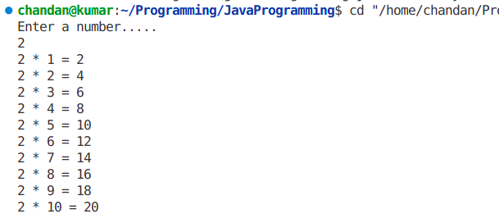
2.for each loop:- In computer programming, foreach loop (or for each loop) is a control flow statement for traversing items in a collection. foreach is usually used in place of a standard for loop statement.
Code->
public class forEach {
public static void main(String args []){
String str[] = {"chandan","harsh","ajit","ankit","aditya"};
for(String v:str){
System.out.println(v);

}

}
}

Output:-

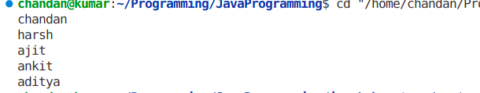
3. while Loop:- The while loop is used to repeat a section of code an unknown number of times until a specific condition is met
Code->
import java.util.*;

public class whileLoop {
public static void main(String args[]) {
Scanner scn = new Scanner(System.in);
System.out.println("Enter a number.....");
int num = scn.nextInt();
int a = 1;
while (num!=0) {
System.out.println(a++);
num--;

}

}
}

Output:-
